**01/08/2023 (Leb)**

* Basic Component of IoT (Self reading)
  + Basic Component of IoT cloud base
    - Sensors/Actuators
    - Device
    - Gateway
    - Cloud

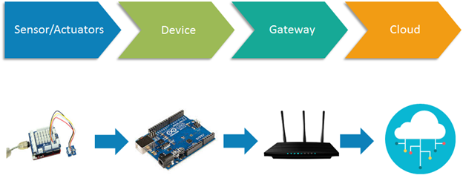

* + 4 stages of IoT Architecture
    - Sensors/Actuators
    - Internal Gateways / Data Acquisition System
    - Edge IT
    - Data center / Cloud

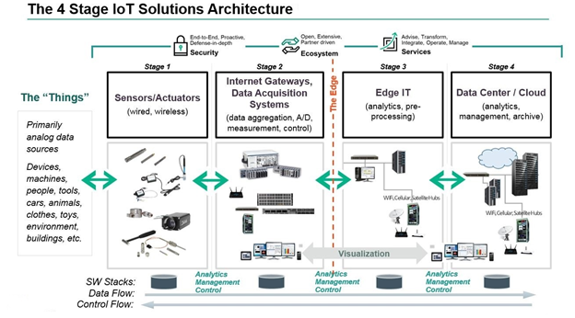

* Sensors
  + Accelerators
  + Magnetometers
  + Gyroscope
  + Acoustic Sensor
  + Pressure Sensors
  + Humidity Sensors
  + Temperature Sensors
  + Proximity Sensors
  + Image Sensors
  + Light Sensors
  + Gas RFID Sensors
  + Micro flow Sensors
* Warble Devices
* Standard Device
  + Desktop
  + Tablet
  + Cellphone
* Bio-Device

**02/08/2023**

* Syllabus

**03/08/2023**

* History of IoT
* The Future of IT
  + Real-Time Network
  + Optimization
  + Intelligent
  + Connected machines
* The Potential of IoT
  + Aviation
  + Power
  + HealthCare
  + Rail
  + Oil and Gas
* Major Potential of IoT
  + Improved Performance
  + Reduced Costs
  + Create Innovative Services
  + New Revenue Stream
* Technological Road map of IoT (From which technology we start and where we are right now)
* IoT Definition
  + **“The Internet of Things (IoT) is a system of interrelated computing devices, mechanical and digital machines, object, animals or people that are provided with unique identifiers and the ability to transfer data over a network without requiring human-to-human or human-to-computer interaction”**
* How IoT Works?
  + Sensor/Devices
  + Connectivity
  + Data Processing
  + User Interface
* Benefits Of IoT
  + Monitoring
  + Improve experience of customers
  + Save time and money
  + Enhance employes productivity
  + Integrate and adapt business models
* Why IoT is so Important